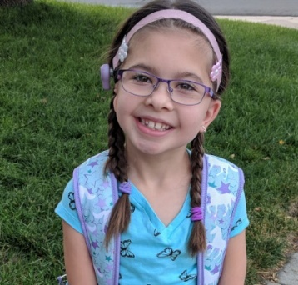
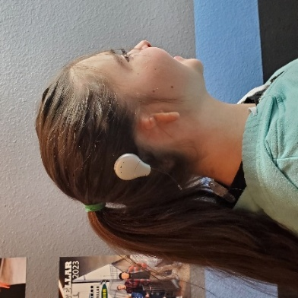
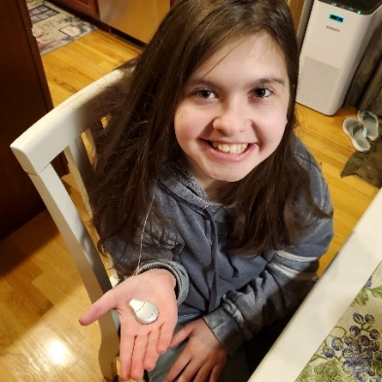
August 7, 2025
Congressman or Senator X
Address:
Washington, DC Zip:
Re: Ally’s Act, H.R. 4606/ S. 3400
Dear Congressman or Senator X,
My name is (full name). I would like to ask you to support a bill that matters to my family. This bill is called Ally’s Act, named after a little girl who was born without a right ear with hearing loss. Ally’s Act is a Federal bipartisan piece of legislation that would help children like Ally and my daughter or son (insert name). Sometimes, babies are born without ears, just like Ally (or your child’s name). Without an ear, my child cannot benefit from a traditional hearing aid. However, when given access to hearing with a specialized hearing device called a Bone Anchored Hearing Aid (BAHA/OID), children like my daughter can have the opportunity to thrive and live a productive life. I would like to ask you to support this bill!
In addition to children and adults who are born with hearing loss, sometimes people lose their hearing overnight unexpectedly. Some may have tumors removed that permanently damage hearing. Others may lose their hearing due to head trauma or chronic ear infections while others from drug ototoxicity due to taking prescription drugs during medical treatments. Many of these individuals can only benefit from a bone conduction hearing aid (BAHA/OID) or a cochlear implant and it is only these specific hearing device systems that will help give them their lives back! Traditional hearing aids will not.
I am writing to respectfully ask you to cosponsor Ally’s Act! This Act remains a small, focused bill that would help the 400,000 children and adults who are left out by their private insurers when it comes to coverage for specific hearing device systems known as Bone Anchored Hearing Aids (BAHA/OIDs) and cochlear implants. It is only these hearing device systems that these individuals can benefit from, which insurers frequently deny. These denials continue to happen, every day, denying children like Ally, and adults the access they need to hear so they can thrive in their communities. Please help us put a stop to this unfair picking and choosing of coverage by our insurers!
We continue to struggle with the same private insurers denying coverage of these medically necessary hearing devices. While doctors have decided these hearing devices are necessary, it’s really the insurance company that is making the medical decision when a denial is issued. Different people need access to these devices for different reasons. When private insurers only cover some people with insurance and yet deny others who are also insured under the same to similar plans – it creates uncertainty for consumers by establishing financial barriers for those who already paid for private insurance. Especially, when specific medically necessary devices are purposely “excluded form coverage”. Private insurers often override the medical professional diagnosis of our medical doctors when denying these hearing devices, which give leverage to the bad actors. Passage of Ally's Act would make this coverage fair & consistent.
Here is Ally when she was 9 years old.
Please help us Lead Ally’s Act to passage!
Thank you for considering this request and for your
continued commitment to improving healthcare access
and positive outcomes for those with hearing loss. My
family appreciates your support and all that you do!
Thank you,
Ally today, 15 years old.
Name: Melissa X
Address: 12345
Broomfield, CO 00000
Ph: 123-456-7898
E-mail: X@gmail.com

